**Task 1:**

1.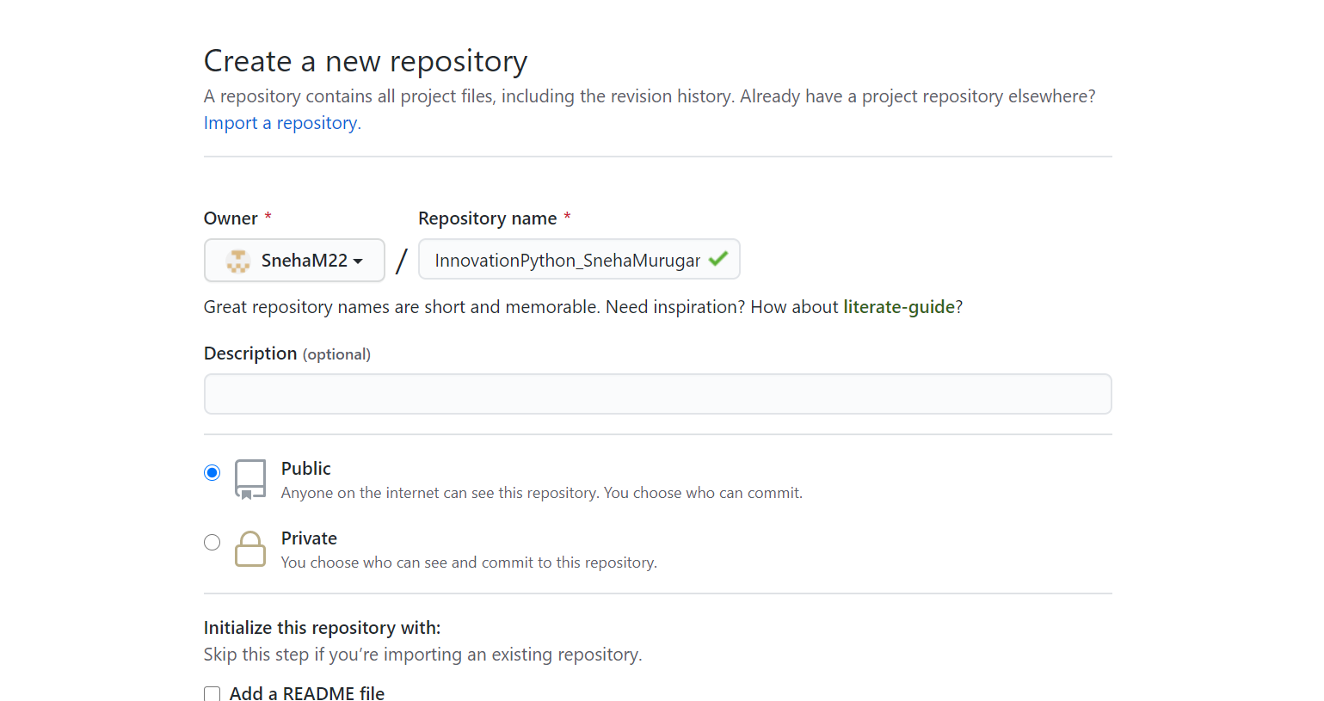

2. Git is a version control system that lets you manage and keep track of your source code history. GitHub is a cloud-based hosting service that lets you manage Git repositories. If you have open-source projects that use Git, then GitHub is designed to help you better manage them

3. Git Workflow is a recipe or recommendation for how to use Git to accomplish work in a consistent and productive manner. Git workflows encourage users to leverage Git effectively and consistently. Git offers a lot of flexibility in how users manage changes.

4. There are two types of version control systems: Centralized, Distributed

5. Branching is used while developing new features for existing programs so that main branch is not affcted if there is any error in the code. New commits are recorded in the history for the current branch, which results in a fork in the history of the project.

6. Forking Workflow begins with an official public repository stored on a server. But when a new developer wants to start working on the project, they do not directly clone the official repository. Instead, they fork the official repository to create a copy of it on the server.

**Task 2:**

